M_10_L_10 | Hyperbeln | M_10_L_10 | Hyperbeln | M_10_L_10 | Hyperbeln
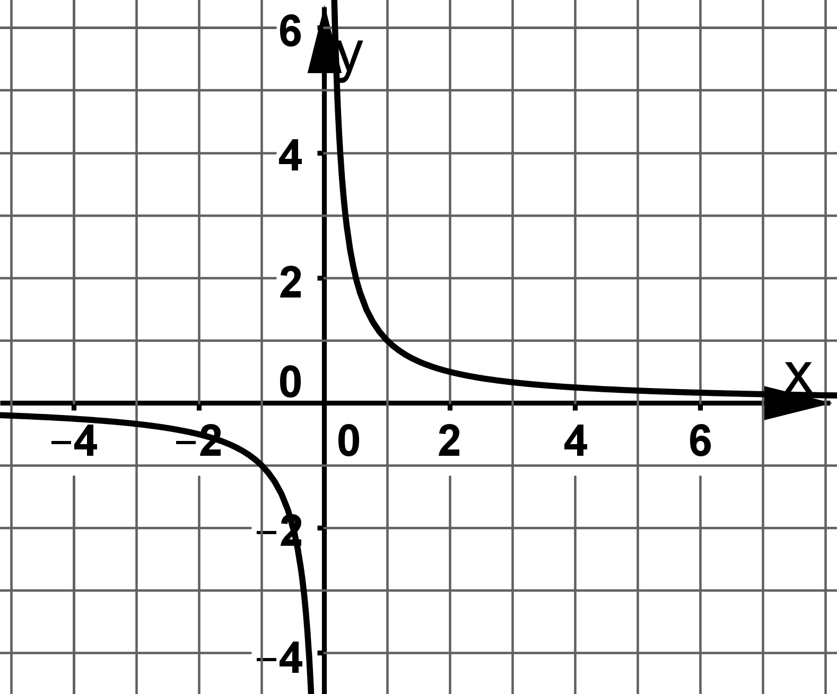 | 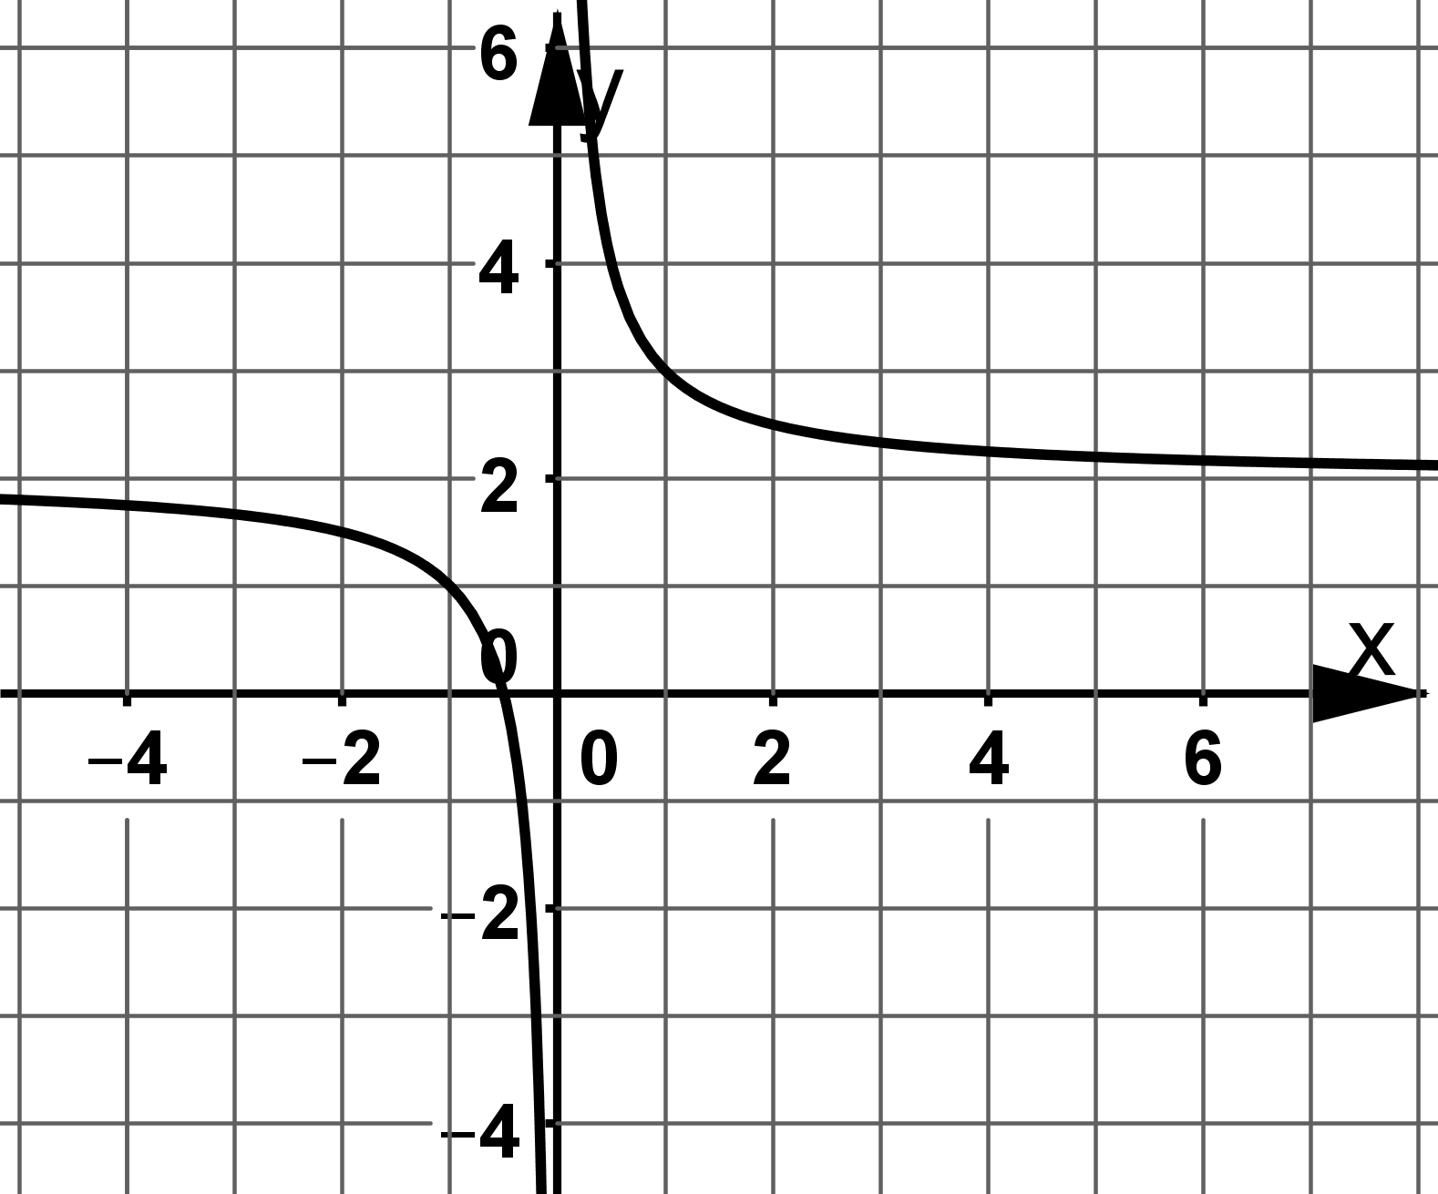 | 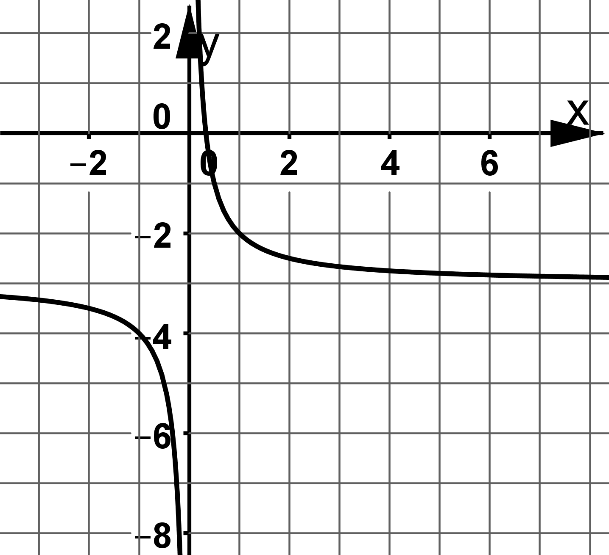
M_10_L_10 | Hyperbeln | M_10_L_10 | Hyperbeln | M_10_L_10 | Hyperbeln
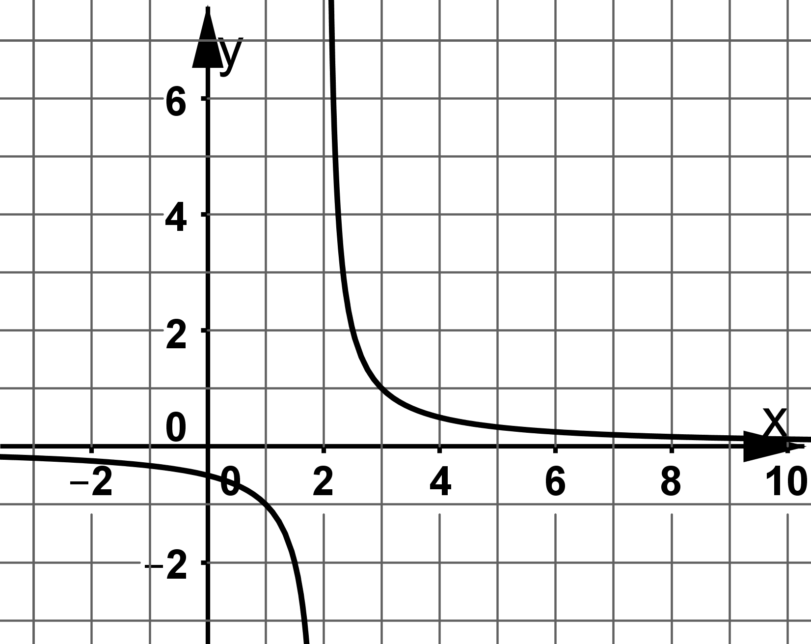 | 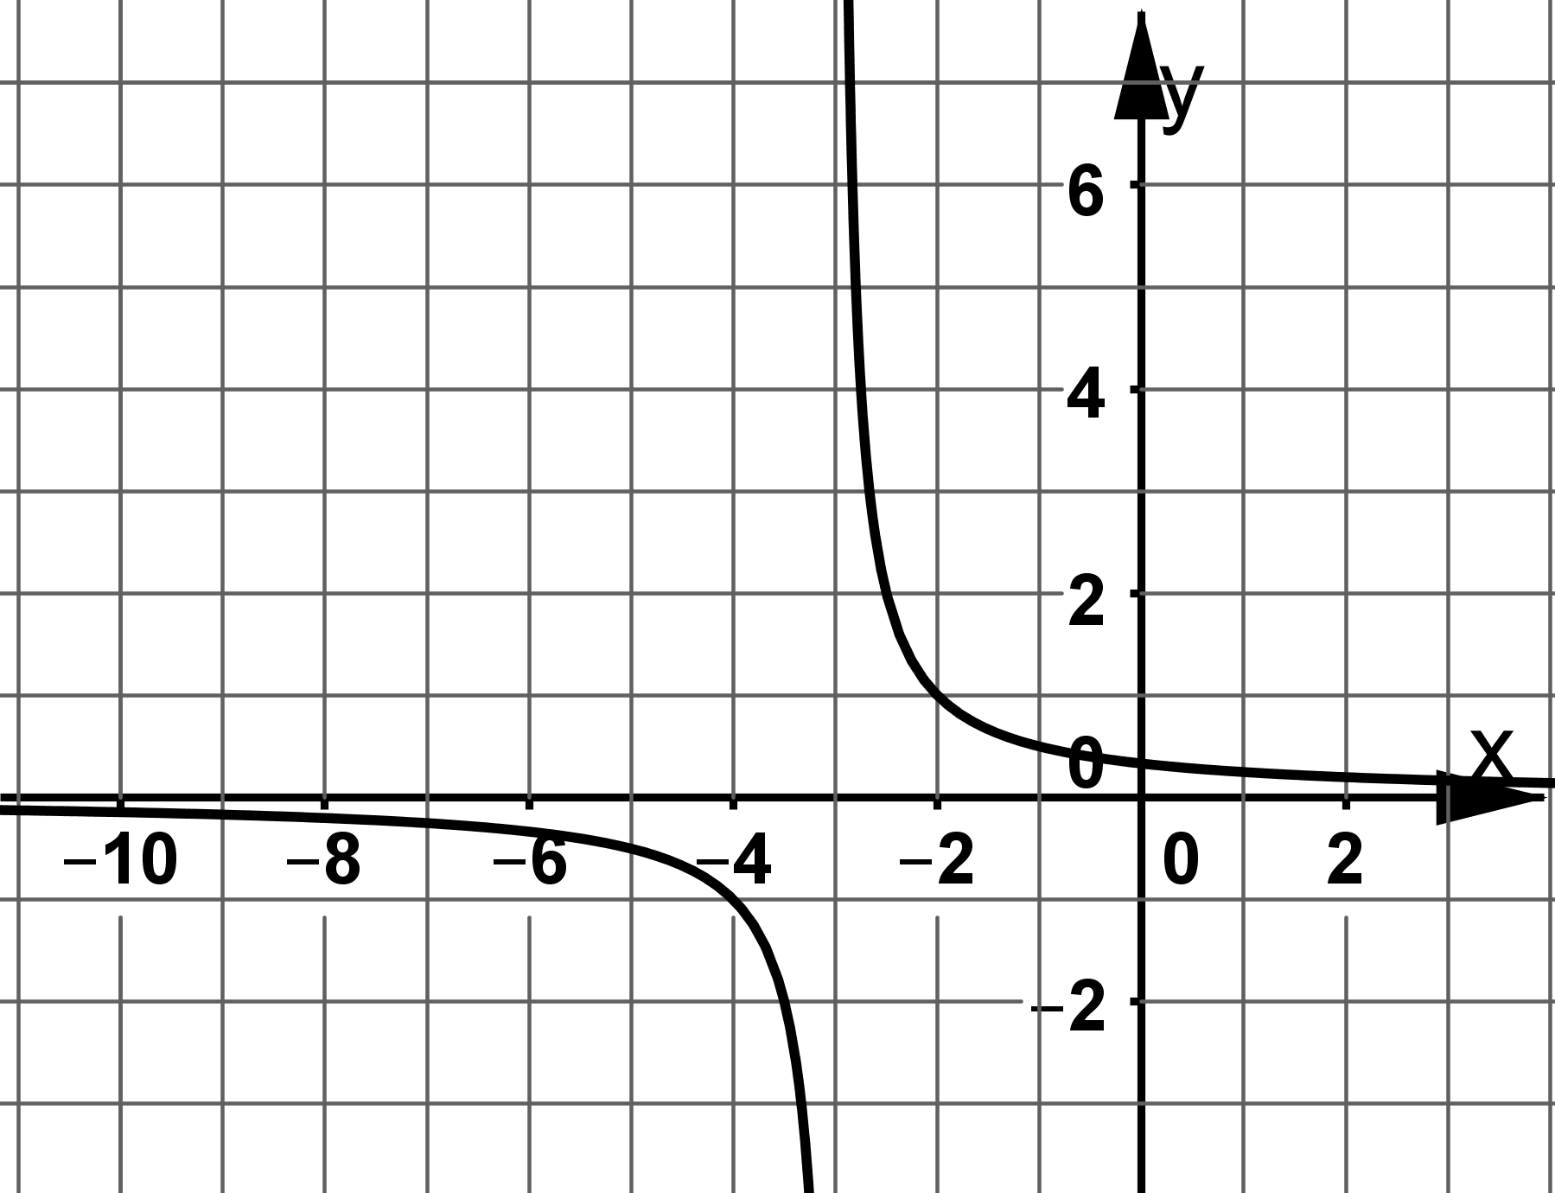 | 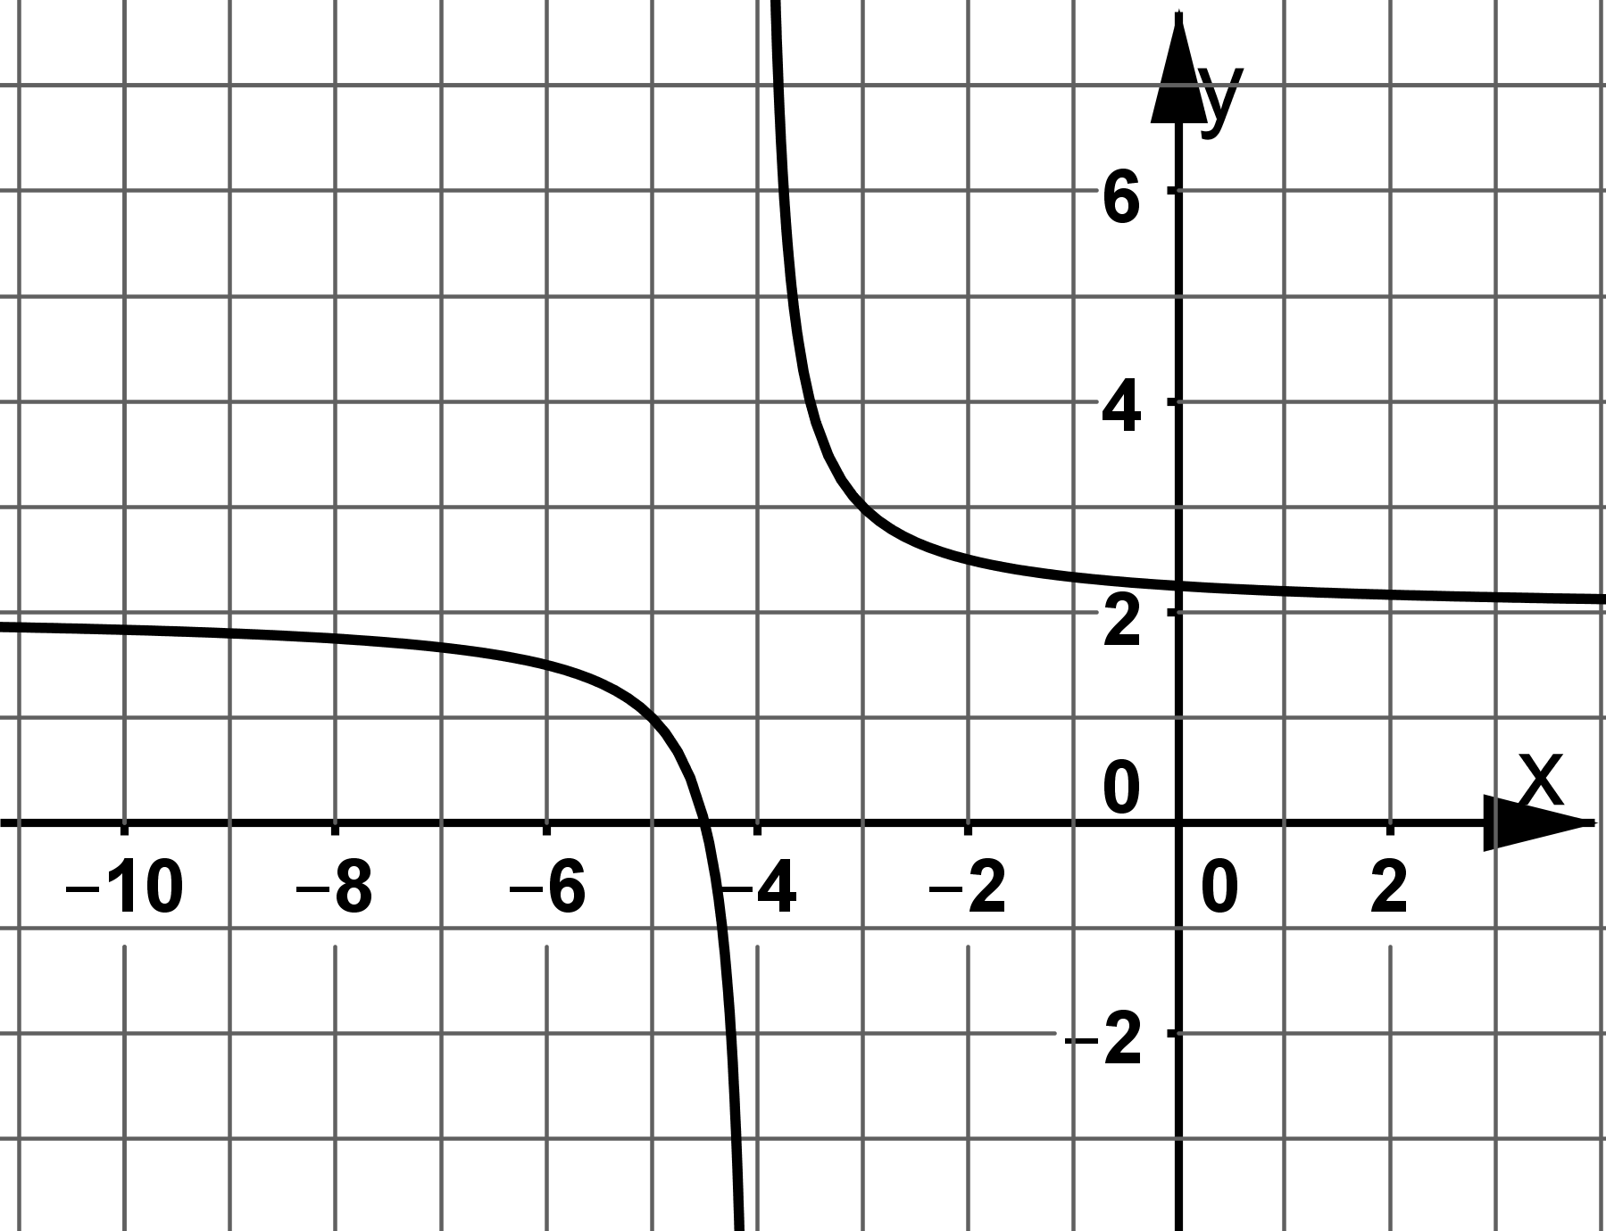
M_10_L_10 | Hyperbeln | M_10_L_10 | Hyperbeln | M_10_L_10 | Hyperbeln
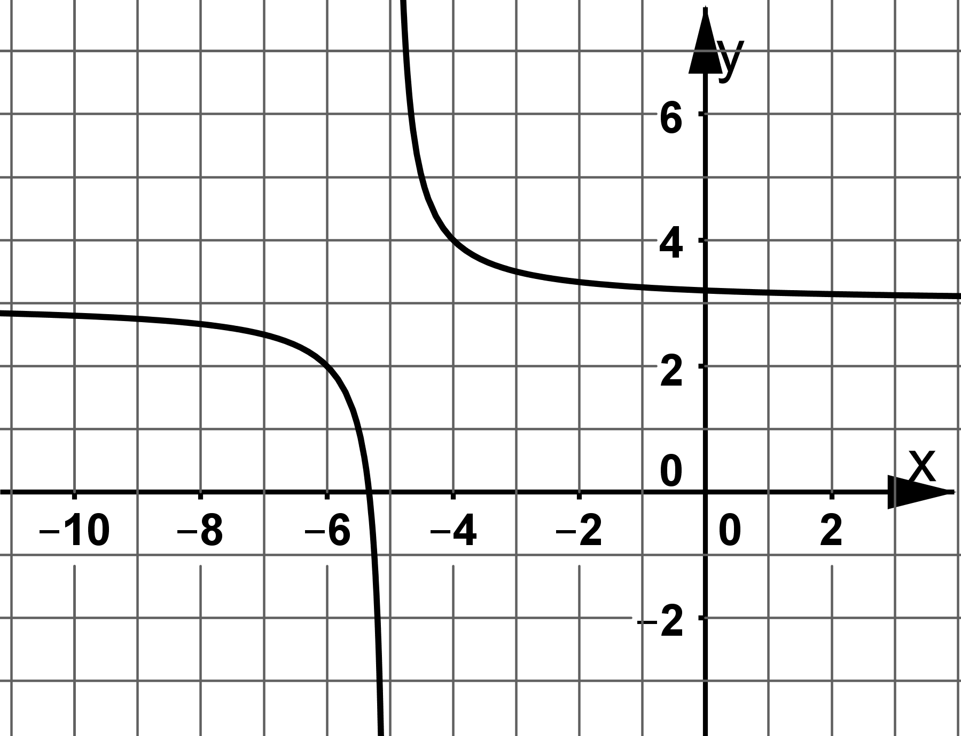 | 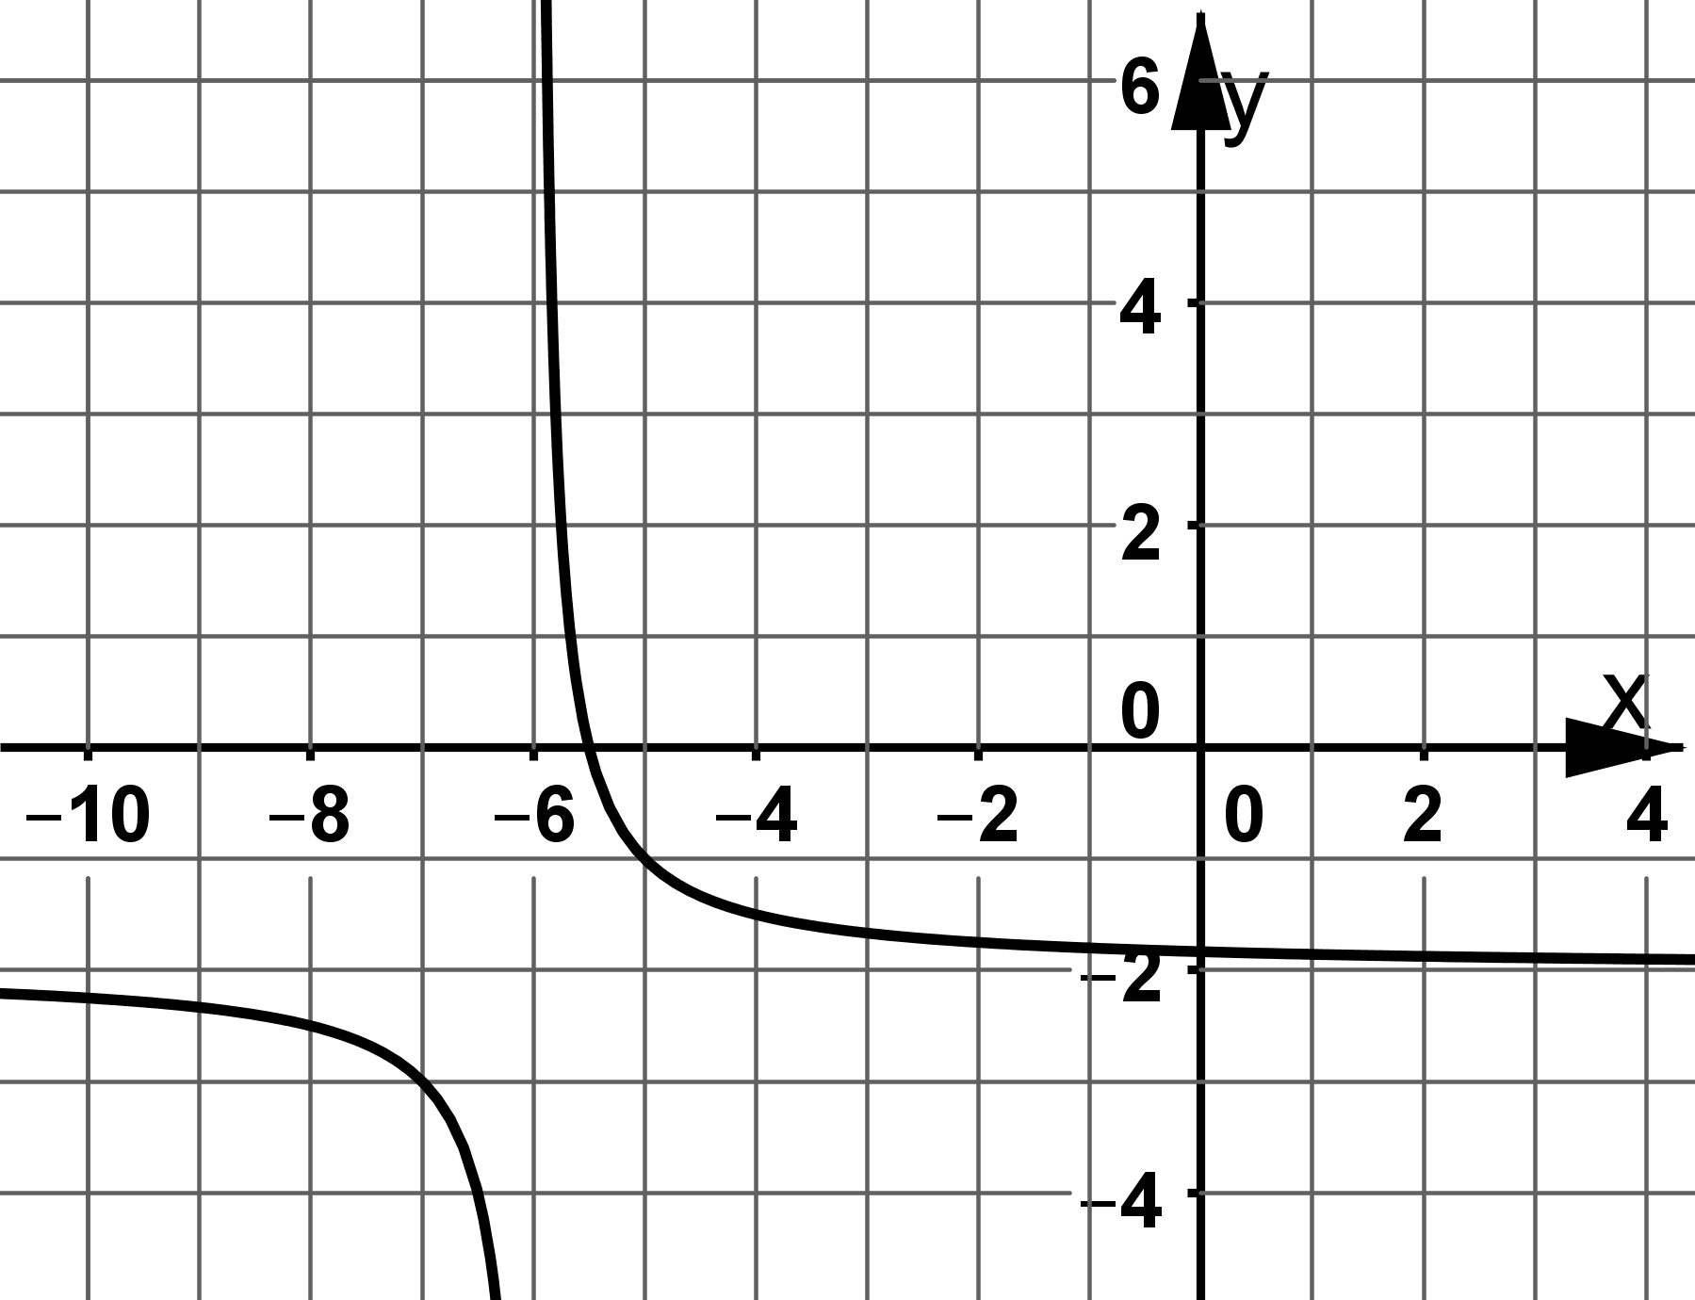 | 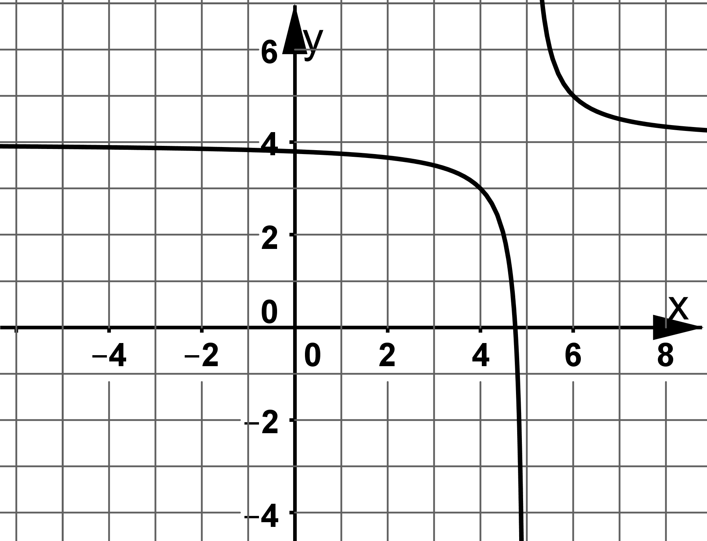
M_10_L_10 | Hyperbeln | M_10_L_10 | Hyperbeln | M_10_L_10 | Hyperbeln
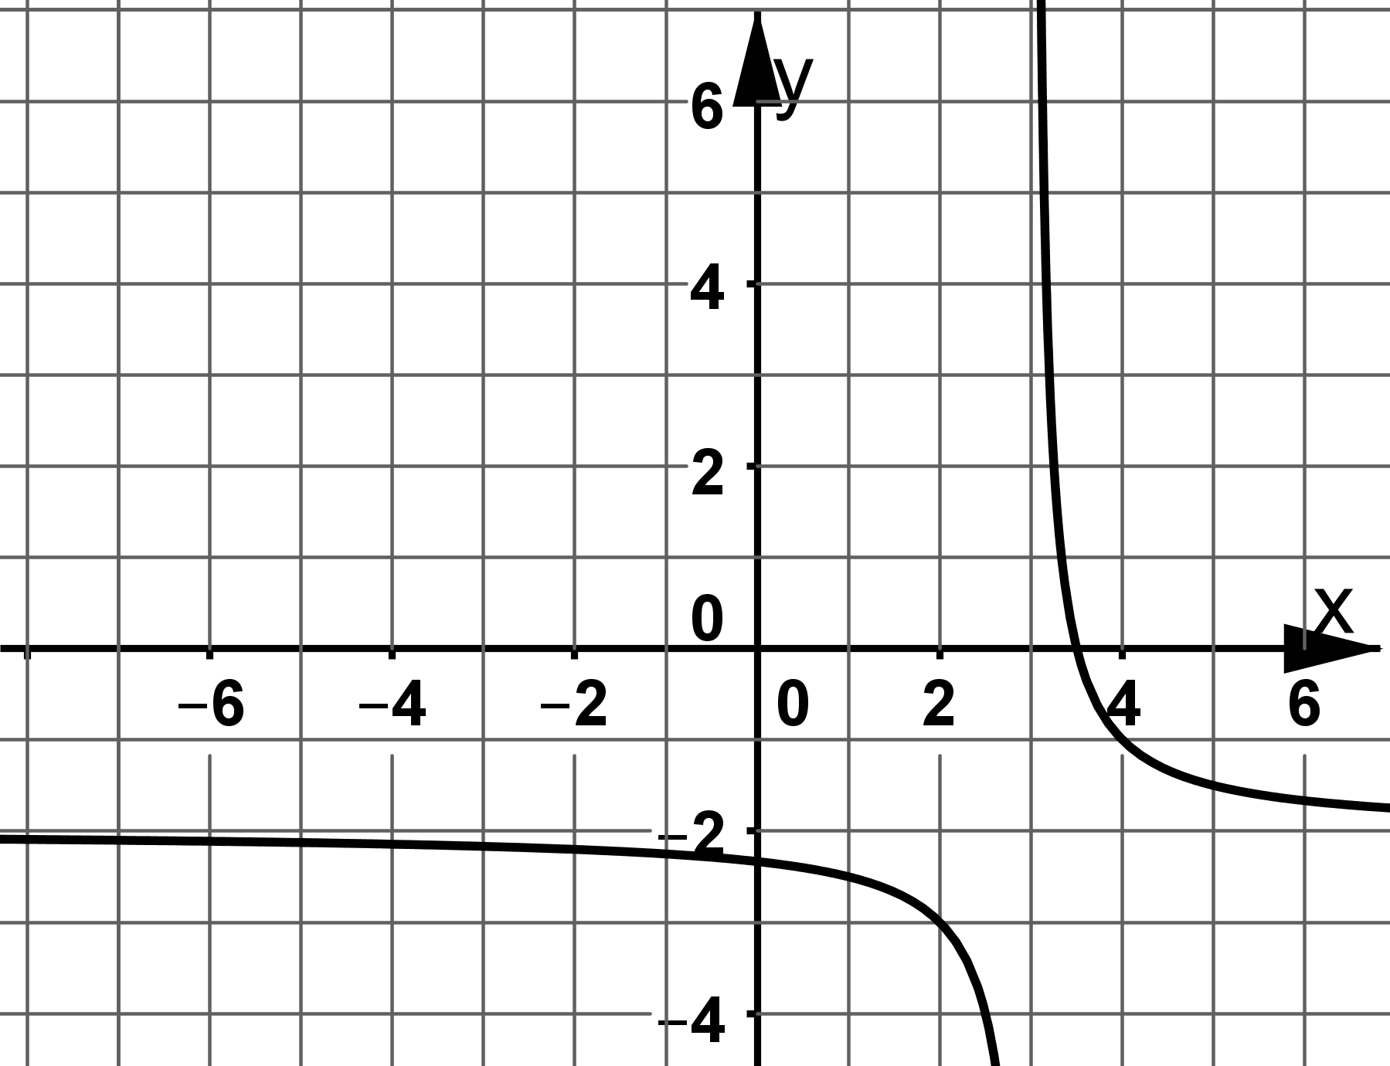 | 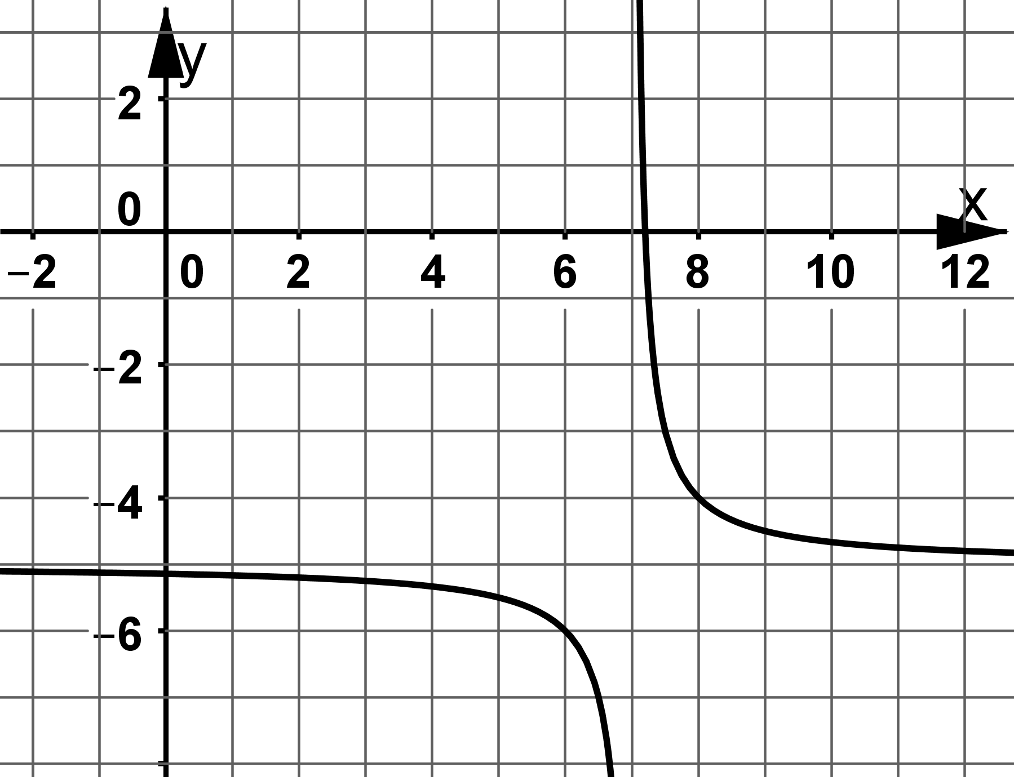 | 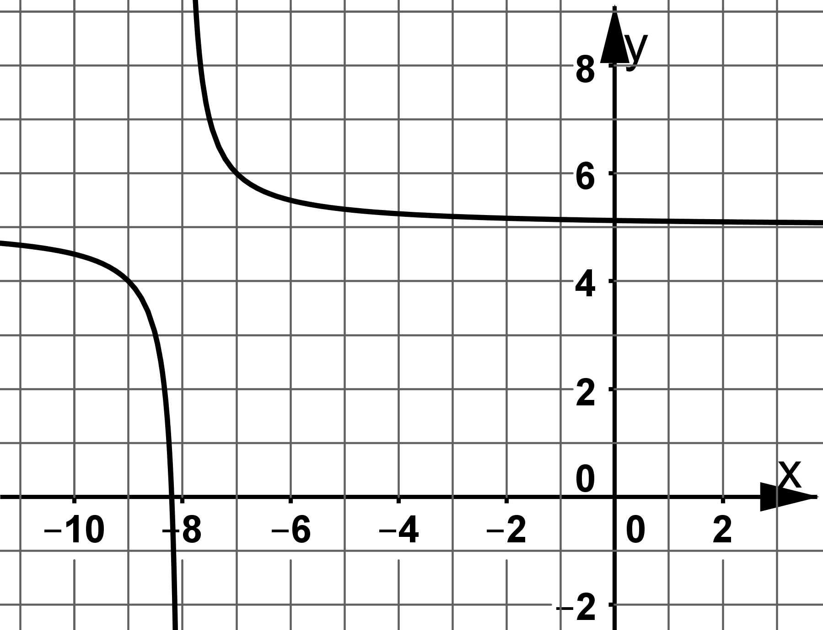
M_10_L_10 | Hyperbeln | M_10_L_10 | Hyperbeln | M_10_L_10 | Hyperbeln
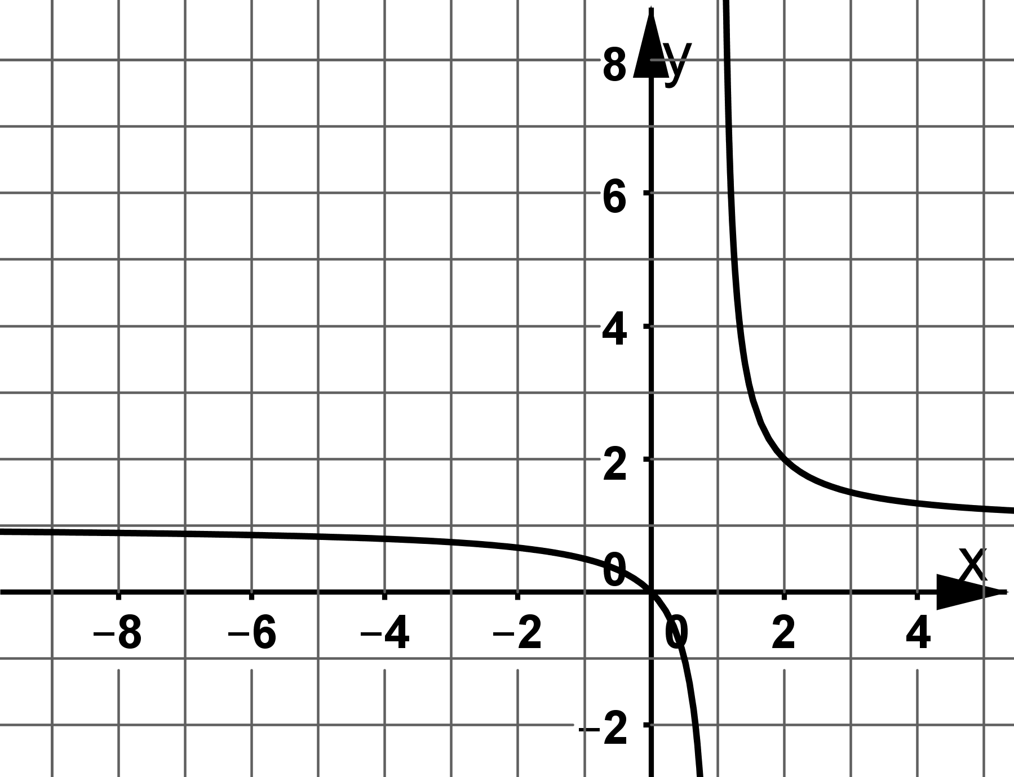 | 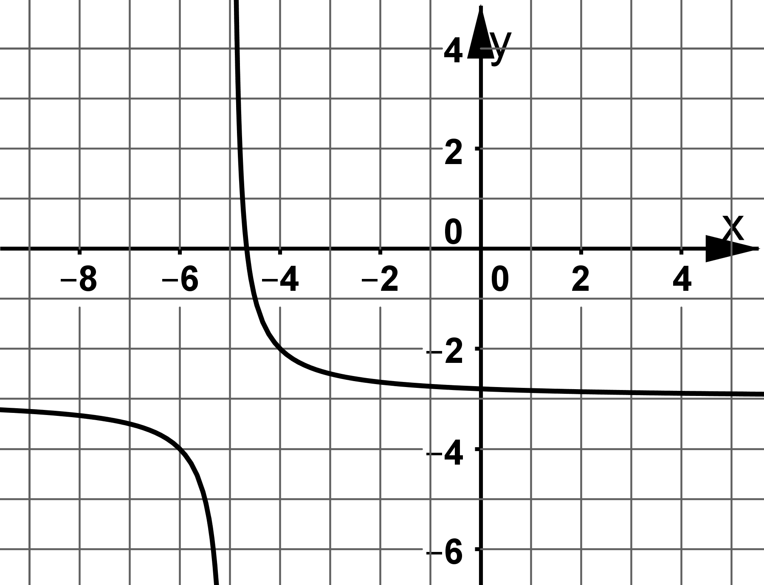 | 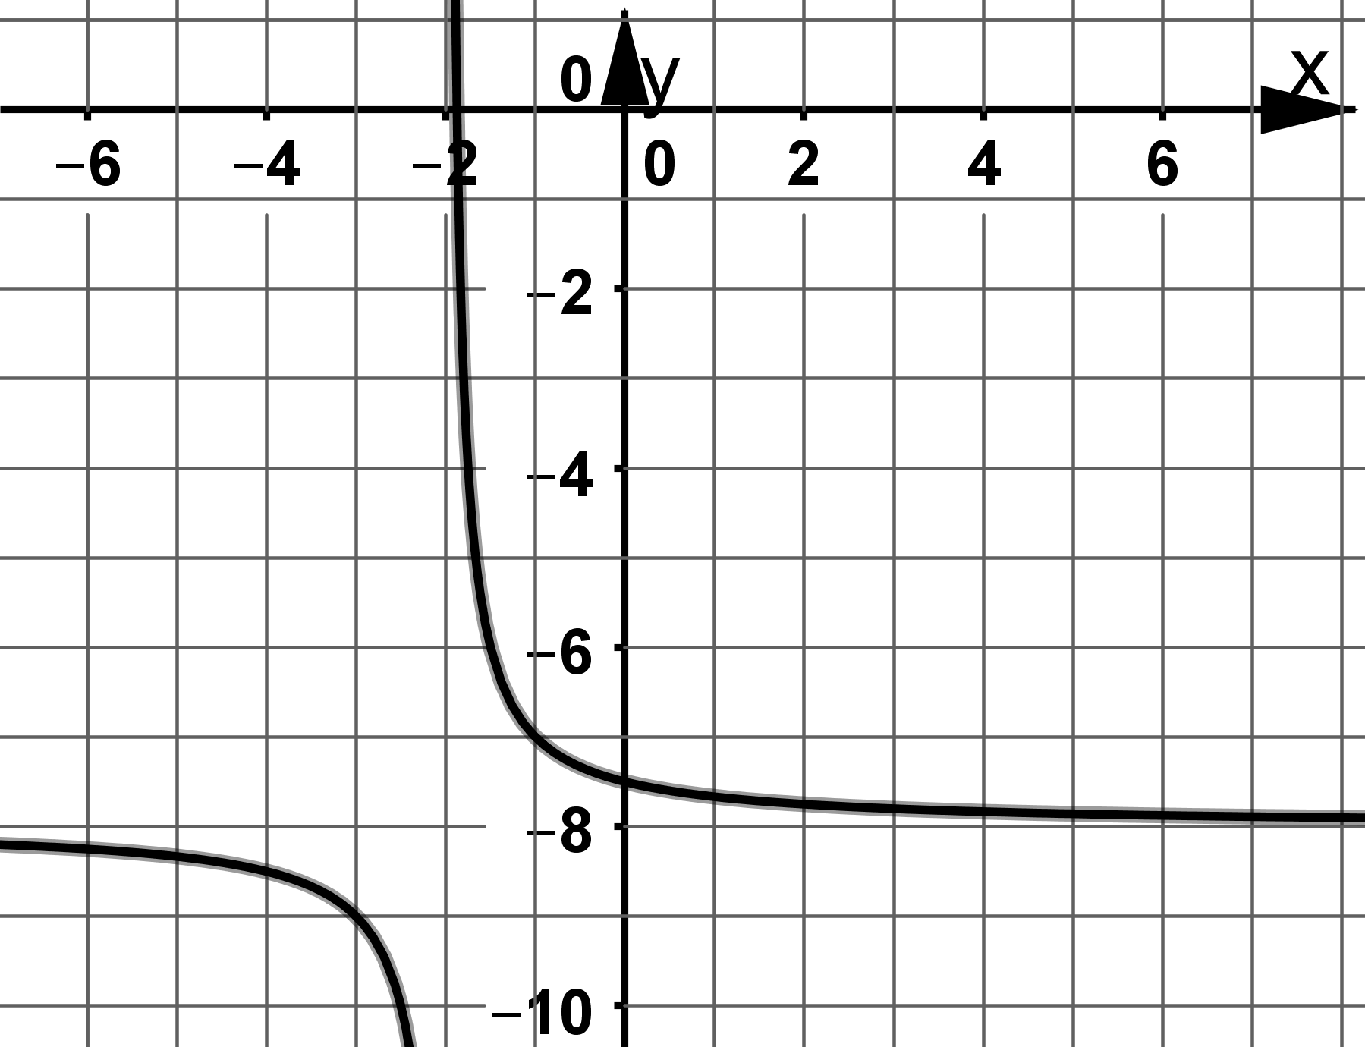
03 | 02 | 01
06 | 05 | 04
09 | 08 | 07
12 | 11 | 10
15 | 14 | 13

